Playwright with Typescript
- By SDET QA (2025 Series)
Day1: Setup Environment & Writing Tests
How to install playwright in local machine?
- Create new folder in local machine
- Open VS Code and terminal
- Run the command “npm init playwright@latest”
- playwright.config.ts # Playwrirght Test configuration
  - testDir # test file location
  - fullyParallel: true, #Run tests in files in
  - projects > browsers configurations are known as workers and it runs all the browsers
  - reporter: 'html' #reporter extension
  - trace: 'on-first-retry', #collect trace when retry failed
  - projects: [ {chromium}]
- package.json # all dependency of the project (for nodejs based project)
- package-lock.json # Or yarn.lock / npm-lock.yaml
- tests/ # Store all the testscript files with spec.ts
Create new test file in test folder?
- Create new file with .spec.ts extension
- test and expect are the functions in playwright
- test is the function is used to write the testcases
- expect is the function used to write assertions
How to use test function?
- Test function takes two parameters i.e. Name of the test & arrow function
- Syntax: test(‘’,()=>{
- //code
- })
- Arrow functions require fixture to interact i.e page
Fixtures
- Fixtures are global variable in playwright
- Playwright provides fixtures such as page, browser, browser context

Async-await
- There are two keywords async await in javascript
- We always need to use async function with keyword aysnc as every async function returns the promise because each function does some kind of background activity
- Every step in the playwright returns the promise, hence we need to use await keyword to wait for steps to get completed
Best practice:
- Each test function should have only single assertions because expect is hard assertion
To run the any test with title of the test
- npx playwright test -g “verify title”

Day 2: Playwright Built-In Locators

DOM (Document Object Model)
- DOM is an API interface provided by the browser.
- When a web page is loaded, the browser automatically creates the DOM structure at runtime.
- Inspect the web page in the browser to interact with the DOM.

Locator
- A locator is used to identify a web element on a web page.
- Playwright built-in locators have auto-waiting and retry-ability features.
- Locator is also a fixture.
- There are 3 types of locators in Playwright:
  - Playwright built-in locators
  - CSS
  - XPath

Playwright Built-In Locators
Note: await is not necessary for locators because they do not return a promise.
- page.getByAltText()
  - Identifies images based on the alt attribute.
  - Use this locator when your element supports alt text, such as img and ARIA elements.
- page.getByText()
  - Finds elements by the text they contain (substring or exact match).
  - Locates elements by visible text.
  - Use this for non-interactive elements like div, span, p.
- page.getByRole()
  - Finds elements by implicit and explicit accessibility attributes.
  - Role is not an attribute.
  - Role locators include buttons, checkboxes, headings, links, lists, tables, etc.
  - Use this for interactive elements such as:
    - button, input, link, checkbox, dropdown
    - list, table, heading, textbox, radio
    - slider, img, banner, form, searchbox
    - option, listitem, rowcolumn, rowheader
- page.getByLabel()
  - Finds elements by the label’s text.
  - Used for form fields with visible labels.
- page.getByPlaceholder()
  - Finds elements by placeholder text.
  - Used for inputs without a label but having a placeholder.
- page.getByTitle()
  - Locates elements by their title attribute.
  - Use when the element has a meaningful title attribute.
- page.getByTestId()
  - Locates elements based on the data-testid attribute (other attributes are customizable).
  - Used when the attribute is data-testid and text or role locators are not stable.

Day3: XPath Locators
- XPath stands for XML path language
- It is syntax used to navigate through the elements and attributes in an XML document
- In web automation, XPATH is used to locate an elements on the web page
Types of xpath
- Absolute Xpath(full xpath)
- An absolute xpath provides the full path from the root of the document to the target element
- It starts with a single /, which represents the root node
- Example: html/body/header/div/div/div[2]/input
- Relative XPath (partial xpath)
- A relative xpath is more flexible way of finding an element. It directly jumps to the element using attributes, without starting from the root.
- It starts with //, which allows xpath to search anywhere in the document
- Example: //*[@name=”search”]
Which xpath should be preferred?
- Relative xpath is preferred because it is shoter, easier to maintain, less likely to break if webpage structure changes

Absolute XPath | Relative XPath
Starts with / | Starts with //
Uses the full path from the root node | Does not require the full path
Traverses through every node in the DOM | Directly targets elements
Does not use attributes | Uses attributes like id, class, name
More dependent on page structure | More flexible and reliable
Breaks easily if DOM changes | Less affected by DOM changes
Example: /html/body/div[1]/input | Example: //input[@id='username']

Day4: XPath Axes Locators
What are XPath Axes?
- XPath axes define the relationship between the current node and other nodes in the XML/HTML document.
- They allow navigation:
  - Upward (parent, ancestor)
  - Downward (child, descendant)
  - Sideways (siblings)
  - Forward / Backward in the document

Here are the primary XPath axes:
- self
- parent
- child
- ancestor
- descendent
- following
- preceding
- following-sibling
- preceding sibling

- Self-Axis: This means self-element/ current node itself
Syntax: “//td[text()=’Germany’]/self::td”
- Parent Axis: Selects the immediate parent of the current node
  - B2 is parent element
  - Y2 is child element
  - Syntax: “//td[text()=’Germany’]/parent::tr”
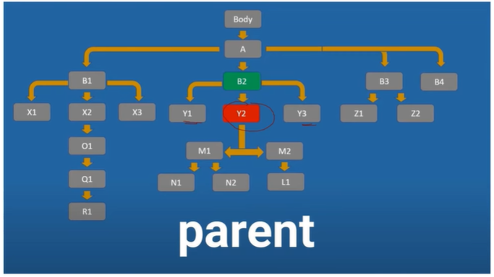
- Child Axis: Selects direct children of the current node
  - Y1, Y2, Y3 is child element
  - B2 is parent element
  - Syntax: “//table[@id=’customers’]//tr[2]/child::td”
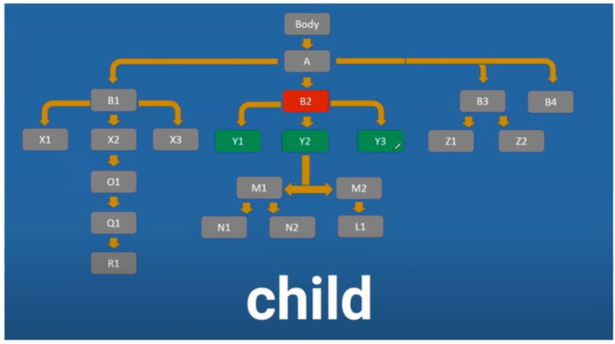
4. Ancestor Axis: Selects parent, grandparent, and higher-level parents
  - B2, A, Body is ancestor
  - Y2 is self node
  - Syntax: “//td[text()=Germany’]/ancestor::table”

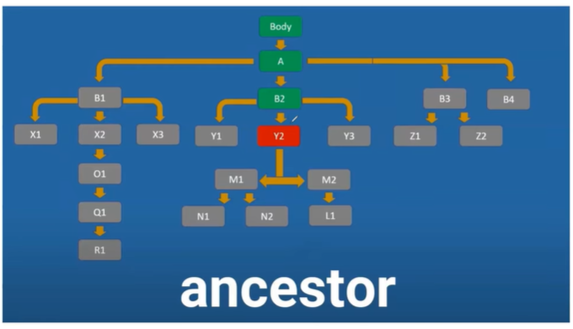
5. Descendant Axis
- Selects all child, grandchild, and deeper elements
- Syntax: “//table[@id=’customers’]/descendent::td”

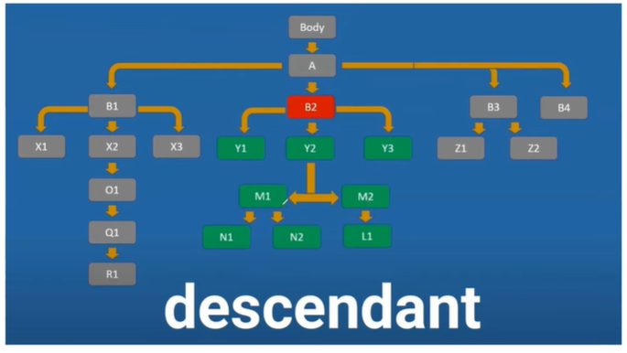

6. Following Axis
- Selects all nodes that appear after the current node in the document
- Includes nodes outside the same parent
- Syntax: “//td[normalize-space()=’Germany’]/following::td[1]”
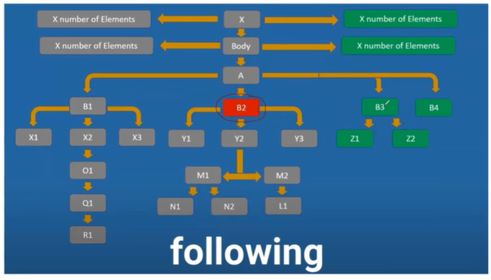

7. Following-Sibling Axis
- Selects only sibling elements that come after the current node
- Must have the same parent
- Syntax: “//td[normalize-space()=Maria Anders’]/following-sibling::td”
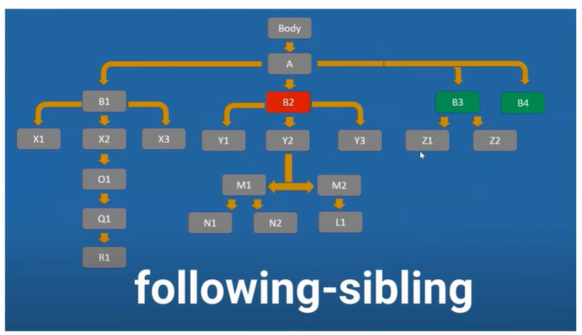

8. Preceding Axis
- Selects all nodes that appear before the current node in the document
- Includes nodes outside the same parent
- B1 and all its children are preceding elements for B2
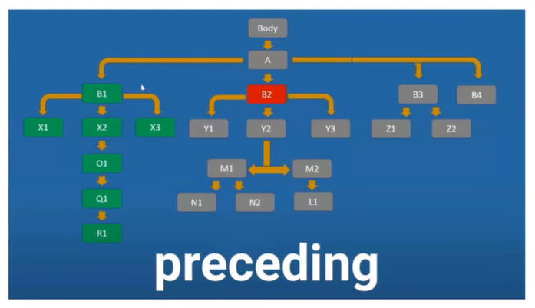
- Preceding-Sibling Axis
- Selects only sibling elements that come before the current node
- Must have the same parent
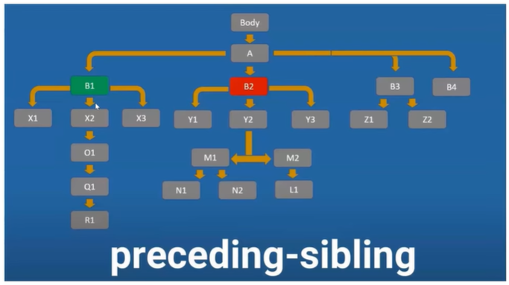

Day5: CSS Selector
- CSS means cascading style sheets
There are 2 types of CSS locator
- Relative CSS locator
- Absolute CSS locator
4 ways to create CSS locator
- Tag with id => tag#id
- Tag with class => tag.class
- Tag with any other attribute =>tag[attribute=value]
- Tag with class and attribute =>tag[]

Note: We never use absolute CSS in automation
Page.waitForTimeout(2000)// This is used to put intentional wait for page to before close

Day6: Handling HTML Elements
- HTML elements such as text input, checkboxes, radio buttons, select options, mouse click, type characters, keys and shortcuts as well as upload files and focus elements.
- Text Input Action Methods
  - toBeVisible() - Checks whether the input field is visible.
  - toBeEnabled() - Verifies the input is enabled (not disabled).
  - getAttribute(<attributeType>) – return value of attribute
  - toBe() – Used for exact match assertion (values, text, attributes).
  - fill() – Enters text into the input field (clears existing text first).
  - textContent() – Returns the text inside an element (For inputs, this is usually empty. Use it for labels, spans, divs)
  - inputValue() – Returns the current value entered in an input field.
- Radio buttons & Checkbox
  - isChecked() – Checks whether checkbox/radio is checked (returns true/false).
  - check() – Checks a checkbox or radio button.
  - uncheck() – Unchecks a checkbox (radio buttons cannot be unchecked).
  - toBeChecked() – Assertion to verify checkbox or radio is checked.
  - not.toBeCheck() – Assertion to verify checkbox or radio is unchecked.
    - Select specific checkbox (Sunday)
    - Filter out the values of checkboxes using map method and assert
    - Select all checkboxes and assert each is checked
    - Uncheck last 3 checkboxes and assert using slice() method
    - Toggle checkboxes: if checked, uncheck; if unchecked, check. Assert state flipped.
    - Randomly select the checkboxes by index (1,3,6) and assert
    - Select the checkbox based on the label

Day7: Actions | Static Dropdowns | Select Options | Part1
Types of dropdowns
- Static dropdown/Single-Multi select – Select tag – options remain static
- Dynamic/Auto suggest dropdown – Bootstrap dropdown - options keep changing dynamically
- Hidden dropdown (Hover based dropdown) --

  - Single select dropdown (static dropdown)
4 ways to select value from dropdown for select attributeType
- By using selectOption() method //by visible text => ‘India’
- By using selectOption() method //by attribute => {attribute:’attributeValue’}
- By using selectOption() method //by label => {label:’India’}
- By using selectOption() method //by index => {index:3}
Capture value from dropdown
- textContent(): To capture single text from dropdown
- allTextContent(): To capture single text from dropdown
Do operations
- Select the option from the dropdown
- Check number of options in the dropdown
- Check the ‘Japan’ option is present in dropdown
- Print all options from the dropdown

  - Multi Select Dropdown
Listbox: Multiselect dropdown are also called as listBox
4 ways to select value from dropdown for select attributeType
- By using selectOption() method //by visible text => [‘red’,’green’,’white’]
- By using selectOption() method //by value attribute => [value]
- By using selectOption() method //by label => [{label:Red’},{labe:’Yellow’}]
- By using selectOption() method //by index => [{index:3},{index:4}]
Capture value from dropdown
- textContent(): To capture single text from dropdown
- allTextContent(): To capture single text from dropdown
To Do:
- Select the option from the dropdown
- Check number of options in the dropdown
- Check the ‘Japan’ option is present in dropdown
- Print all options from the dropdown
Sorted dropdown
How to check if array is sorted or not?
- Capture all the elements from array
- Store all captured elements to new array
- Convert array into sorted array
- Compare both the array and use spread operator for exact comparison

How to check if array has duplicates or not?
- Capture all the elements from array
- Remove the whitespace from array values
- Initiate the unique list using Set
- Initiate the duplicate list using array
- Apply condition to filter out unique and duplicate array elements

Day8: Actions |Bootstrap Dropdowns | Dynamic dropdown| Part2
Types of dropdowns
- Static dropdown – Select tag – options remain static
- Dynamic/Auto suggest dropdown – Bootstrap dropdown - options keep changing dynamically
- Hidden dropdown (Hover based dropdown)

How to locate the dynamic dropdown using selector hub?
- Using selector hub (sometimes not work)
  - Open the selector hub
  - Click on debugger & turn on (This will start after 5sec and screen get freeze)
- Using sources tab (this freezes the UI script) - (sometimes not work)
  - Pause the UI script
- Ctrl+Shift+P – DOM Structure
  - Run > Enter ‘Emulate focused page’ (This freezes the screen)
Note:
- When we get data from dynamic dropdown then we need to put wait when we freeze the screen
- <span>abc</span> - innerText() – this mostly used for input attributes, textContent() – both will work
- <span label=abc>name:</span> -- innerText() will return name:, textContent() will return abc

Todo: flipkart.com
- Get all the suggested options > ctrl+Shift+P on DOM page > Emulate focused page
- Print all auto suggestions options using forloop and innerText(), textContent()
- Print the specific option from list
- Select/click on the smartphone option

Todo: Bootstrap dropdown | orangehrm.com
- Open orangeHRM
- Click on PIM from left menu
- Click on the job title
- Capture all the options from dropdown and count
- Print all the options using forloop and innerText(), textContent()
- Select/click on the job value

Dropdown Type | HTML Tag | Playwright Strategy
Static Dropdown | <select> or custom | Use selectOption()
Dynamic/Auto Suggestion Dropdown | <div>, <ul>, <li> or <input> dynamic list | Click dropdown → Click option  Type → Select suggestion
Hover Dropdown | Hidden menu | Hover → Click

Day9: Handle Web Tables 1 | Extract Text from Page Elements
- for..of loop
- Works only with arrays or iterable objects
- Cannot be used directly on Playwright Locator
- Can be used after converting locator into array using .all()
- Traditional for Loop
- Used when dealing with Locator (not array)
- Requires: count(), nth(index)
The different between innerText() and textContentMethod();
Method | Description
innerText() | Returns only visible text
textContent() | Returns all text (visible + hidden inside span, label, etc.)

- innerText() Vs textContent():
  - innerText(): Returns only visible text
  - textContent(): Returns all text (visible + hidden inside label,span )
Method | Description
allInnerTexts() | Returns array of visible texts only
allTextContents() | Returns array of all texts (visible + hidden)

- allInnerText() Vs allTextContent():
  - allIinnerText(): Returns array of only visible text
  - allTextContent(): Returns array of all text (visible + hidden inside label,span )
Todo:
- Open Demo Web Shop login page: https://demowebshop.tricentis.com/login
- Print values of single element using innerText() & textContent()
- Print values of all elements using allInnerText() & allTextContent
- Print values of all elements using for..of loop

How to Decide Which Loop to Use?
- When a locator matches multiple elements but is stored as a single Locator object, it does not return an array directly, Use a traditional for loop, Access elements using .nth(i)
  - Console.log(await productLocators.nth(i).innerText())
- Use <locator>.all() The locator gets converted into an array of locators.and returns the array of locator (array) that why we need to use for…of loop
  - Console.log(await productLocators.innerText())
- We can also use a for...in loop to iterate over index values of an array and then access elements using those indexes.
  - Console.log(await productLocators[locator].innerText())

Ways to Extract Text from Page Elements
Types of tables
- Static web table
- Dynamic web table
- Pagination web table

Chaing of locator:
- Const table:Locator = page.locator(“table[name=’BookTable’] tbody);
- Const rows:Locator=table.locator(“tr”)

  - Static web table: Table is tag name and locate the table via tbody where tr represent table row and td represent table data
Todo:
- Open URL https://testautomationpractice.blogspot.com/
- Count the number of rows in the table using count() or toHaveCount()
- Count the number of headers/column using count() or toHaveCount()
- Read all data from the second row and assert using toHaveText()
- Get all rowsData, exclude the header and Read all the data from the table and except the column/header using slice()
- Print the book names where author is Mukesh by locating all rows and then apply index for author and books name and compare finally
- Calculate the total price of all books

Day10: Handle Web Tables 2 | Extract Text from Page Elements
Dynamic web table:
- web table contains dynamically changing rows and columns.
Todo:
- Open URL https://practice.expandtesting.com/dynamic-table
- For Chrome process get value of CPU load.
  - Identify and locate the entire table body
  - Capture all rows (<tr>) from the table body.
  - Iterate each row to check Chrome name/process presence
    - Read the first column value using nth(0) to identify the process name.
    - Apply a conditional check If the process name equals "Chrome", then:
    - Locate the CPU load value using a CSS locator:
      - locator("td:has-text('%')") OR locator("td", { hasText: '%' })
      - Extract and store the CPU load value.
- Validate CPU Load Against Yellow Label
  - Locate the yellow box text
  - Use the includes() method to verify that: The extracted CPU Load value is present in the yellow label text.
  - Perform assertion to validate the result.

Pagination Table
- Open URL https://datatables.net/examples/basic_init/zero_configuration.html
- Read Data Across All Pages
  - Initialize Page Control and Store hasMorePages Boolean value to check pages is available in table
  - Use While Loop (hasMorePages) because page count is unknown
  - Locate all rows inside the table body and Store them in a locator array using the all() method.
  - Iterate through each row, Extract required column values, Perform necessary validations or logging.
  - Locate the Next pagination button, Check whether:
    - The button is enabled (not disabled).
    - It does not contain a disabled attribute/class.
  - If enabled: Click on Next. If disabled: Set hasMorePages = false to exit loop.
- Filter rows and validate row count
- Search for specific data across pages
  - Locate the rows, Capture all rows on the current page.
  - Verify whether result rows exist after search/filter.
  - If the desired record is found: Print the matched text, Break the loop, Log message: "Record exists"
  - If not found: Continue pagination.
Apply assertion once match is found, Ensure the expected data equals actual data.

Table Type | Structure | Handling Strategy in Playwright
Static Table | <table> structure | Iterate rows and columns
Dynamic Table | API/AJAX-based | Wait for load, handle updates
Paginated Table | Multiple pages | Loop through pages

Day11: Handle jQuery & Bootstrap Date Pickers
- JQuery type
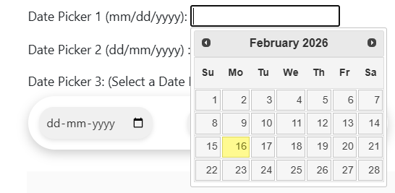
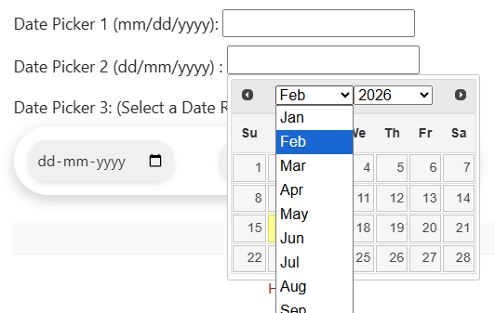
- Bootstrap type
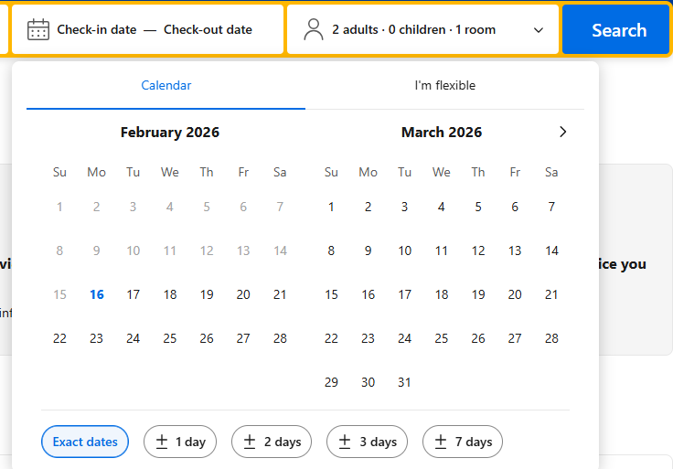
- Range type (booking.com)
- One type which has check-in checkout

Todo | JQuery date picker:
- Navigate to https://testautomationpractice.blogspot.com/
- Locate the JQuery dropdown and check visibility and fill date using fill() method
- Locate the actual Month & year from the first date picker and compare it with target/expected future date and month using while loop
  - If it is not matching then click on next month button
  - If it is matching then break the loop
- Locate all the actual date from each month and compare it with target date
  - If date is matching then select the date and break the loop
- Make the code dynamic the same code for past date selection using only one locator change
- Create the common function to select the date
  - Function named as selectDate with parameter year, month, date and page (from playwright), isFuture
  - Make the function async to support await
  - Check the condition if future date is passed in function then click on next month button else click on past month button

Todo: Bootstrap date picker
- Navigate to https://booking.com/
- Click on the date picker field to open calendar
- Check in date selection
  - Navigate through calendar to find the desired checkin month and year using while loop
  - Select the specific check in date
  - Assertion to confirm checkin date was selected
- Check out date selection
  - Navigate to the required checkout month and year
  - Select the specific check out date
  - Assertion to confirm checkout date was selected

Day12: Handle Dialogs(Alert,Confirm&Prompt),Frames & Inner Frame
What is Dialog ?
- A dialog (alert window) is Not part of the DOM
- Triggered using alert(), confirm(), prompt()
- Automatically dismissed by Playwright by default
- Since dialogs are browser-level popups, Playwright auto-handles them unless we explicitly intercept them.
How Playwright Handles Dialogs?
- By default Alerts, Confirm & Prompt are auto-dismissed
- If you want control → register a dialog handler before triggering the dialog.
Types of alerts
  - Simple alert – This contains only ok button
  - Confirmation Alert – This contains Ok & Cancel button
  - Prompt Alert – This contains textbox, Ok & Cancel button
- Page.On() method: requires two parameters
- Event name → 'dialog'
- Callback function → Arrow function to handle dialog
Method | Description
dialog.type() | Returns dialog type (alert, confirm, prompt)
dialog.message() | Returns dialog message text
dialog.accept() | Clicks OK / Enters value in prompt
dialog.dismiss() | Clicks Cancel
dialog.defaultValue() | Reads default value from prompt

Todo:
- Navigate to https://testautomationpractice.blogspot.com/
  - Handle the simple prompt
    - Click the Simple Alert button
    - Capture the alert
    - Validate the alert message
    - Click OK using dialog.accept()
  - Handle the confirmation prompt
    - Click the Confirmation Alert button
    - Capture the alert
    - Validate the message
    - ✔ Case 1: Click OK using dialog.accept()
    - ✔ Case 2: Click Cancel using dialog.dismiss()
  - Handle the Prompt dialog
    - Click the Prompt Alert button
    - Capture the alert
    - Validate the message
    - ✔ Case 1: Enter text using: dialog.accept("YourText");
    - ✔ Case 2: Click Cancel using dialog.dismiss();
IFrame
- IFrame is inline frame
- An HTML element that embeds one webpage inside another.
- Example: A window inside another window.
- During automation Default focus is on main page, we must switch focus to iframe interact with it.
- Page.frames() – This method Returns an array of all frames on the page.

Two Ways to Handle IFrame in Playwright
  - Using .frameLocator() Method –recommended because it accepts any locator
  - Using Frame Objects
    - Using frame name attribute //.frame(‘<attributeName>’)
    - Using frame URL // .frame({url:<url> })
Todo:
- Navigate to https://ui.vision/demo/webtest/frames
- Iframe handling using page.frame()
  - Locate the frame
  - Enter the text in the frame only if frame is exist
- Iframe handling using frame.locator()
  - Locate the frame
  - Enter the text in the frame only if frame is exist

How to handle inner frame or child frames?
- Navigate to https://ui.vision/demo/webtest/frames
- Locate the frame which has child elements
- Use childFrames() method to interact with child frame & it returns array
- Store the child frame in variable and perform action on the child frame

Day13: Browser Context, Tabs & Pages/Popups
- Each browser has their own browser engine like chromium, firefox, webkit
- Each browser maintains its own browser context i.e. Incognito session
- Browser context stores and maintained the information such as
  - Cookies
  - Local storage
  - Session storage
  - Authentication info
- One browser can have multiple browser context
- Each context can have multiple separate isolated independent browser session for same browser
- Each context can contain multiple pages, and we can open different websites on different pages simultaneously
- In Playwrights, Tab or window or popup considered as Page only
Hierarchy: Worker > browser > browser context > page > testInfo
How to define browser, browser context and page in test?
- Default Page from Playwright Config: When we directly use page inside the test, Playwright automatically provides it from playwright.config.ts.
- Creating an Isolated Browser: To handle an isolated browser instance, we manually launch the browser and store it in a variable
// const browser = await chromium.launch();
- Creating an Isolated Browser Context: To create a new isolated context, we need to import the browser and create a new context object using browser:
// const context = await browser.newContext();
- Creating an Isolated Page: To create a new page in the test, we need to import the context and create a newPage object using context
// const page = await context.newPage();
- Context.pages().length() – This method returns the array of all pages created in context

How to handle multiple tabs/page/window inside one another?
- Scenario: When multiple pages open inside the same browser.
- Approach
  - Create multiple page objects
  - Or capture newly opened pages using events
- When a page opens another page (new tab), We must handle it using context events
- Important: Always start waiting for the event before clicking the element.
// Syntax: Context.waitForEvent('page')
- To achieve this: We need to execute both the events parallelly by using method called as Promise.all()
- Promise.all() method
  - This needs array of promises[<event1>,<event2>]
  - This return array of resolved values (pages).
- Using Promise.all(): To run two asynchronous actions in parallel. It returns array of resolved values (pages).
  - Here we don’t want to run the events synchronously or asynchronously that’s why we used promise.all()

How to switch between the pages & Title?
- Approach1: Using context
  - Find out the total pages using context.pages() method
  - Find the title of the each pages using title() method
  - Switch to page using index //await pages[1].bringToFront();
- Approach2: Using parentPage & childPage
- const parentTitle = await page.title();
- const childTitle = await newPage.title();
Todo:
- Navigate to https://testautomationpractice.blogspot.com/
- Capture the current page
- Click on the New tab button
- Capture the new page using ‘page’ event
- Store all the pages using Promise.all() method
- Use .waitForLoadState() method to load the page/window properly
- Capture title of both the pages
- Switch between the pages using index or title

Popup:
- When the page/window opens separately within same browser its called as Popup
- Playwright handles this using event i.e. ‘popup’
- // page.waitForEvent('popup')

Todo:
- Navigate to https://testautomationpractice.blogspot.com/
- Capture the current page
- Click on the Popup Windows button
- Capture the new window using ‘popup’ event
- Store all the popup windows using Promise.all() method
- Use .waitForLoadState() method to load the page/window properly
- Capture title & url of all the pages/windows
- Switch between the pages using index or title
- Capture the window which has playwright title and perform click on operation on specific one

How to handle the authenticated windows?
- Navigate to https://the-internet-herokuapp.com/
There are 2 ways to pass the credentials into the app
- Directly pass credentials into the URL
  - Page.goto(‘username:password@https//the-internet-herokuapp.com/basic_auth’)
- Directly pass Credentials while creating context
- const context = await browser.newContext({
- httpCredentials:{
- username:'admin',
- password:'admin'}
- });

Day14: Auto waiting, Timeouts, Assertions & Codegen
Actions - Auto-Waits
- Auto-waiting means that Playwright automatically waits for the necessary conditions (Actionable checks) before executing actions like click(), fill(), type() etc.
- The default auto wait time of actions is 30 sec
Before clicking, Playwright will wait until:
- The button is attached to the DOM
- It is visible
- It is enabled
- It is not covered by another element
Assertions – Auto waits
- Playwright includes auto-retrying assertions that remove flakiness by waiting until the condition is met
- The default auto wait time of assertions is 5 sec
Forcing actions
- passing truthy force to locator.click() method will not check that the target element actually receives click events.
Why is Auto-Waiting Useful?
- Reduces flaky tests caused by timing issues
- Makes your tests more stable and reliable
- Improves readability and maintainability

Timeouts
- Timeouts means how long the framework should wait before failing a test or assertion.
- Playwright provides flexible options to manage timeouts globally or locally.
- Local timeout always get override by global time
There are 2 types of timeouts
  - Global
    - Default: 30,000 ms (30 seconds)
    - This can be changed from playwright.config.ts // timeout: 60_000
  - Local
    - This can be changed by test level //Test.setTimeout(5000)
Assertion timeout
- Timeouts means how long the assertion should wait before failing a test or assertion.
- Local timeout always get override by global time
  - Global
    - Default: 5000 ms (5 seconds)
    - This can be changed from playwright.config.ts // expect: {timeout : 1000}
  - Local
    - This can be changed by test level //.toBeVisible({timeout:5000})
Timeout | Default | Description
Test timeout | 30_000 ms | Timeout for each test
Test timeout | 30_000 ms | Set in config
Test timeout | 30_000 ms | { timeout: 60_000 }
Test timeout | 30_000 ms | Override in test
Test timeout | 30_000 ms | test.setTimeout(120_000)
Expect timeout | 5_000 ms | Timeout for each assertion
Expect timeout | 5_000 ms | Set in config
Expect timeout | 5_000 ms | { expect: { timeout: 10_000 } }
Expect timeout | 5_000 ms | Override in test
Expect timeout | 5_000 ms | expect(locator).toBeVisible({ timeout: 10_000 })
Timeout | Default | Description
Test timeout | 30_000 ms | Timeout for each test
Test timeout | 30_000 ms | Set in config: { timeout: 60_000}
Test timeout | 30_000 ms | Override in test: test.setTimeout(120_000)
Expect timeout | 5_000 ms | Timeout for each assertion
Expect timeout | 5_000 ms | Set in config: { expect: { timeout: 10_000}
Expect timeout | 5_000 ms | Override in test: expect(locator).toBeVisible({ timeout: 10_000 })

Assertions
- Auto Retrying-Assertions
  - When assertions are put on the Locator or Page then it works as Auto retry
  - Assertions will retry until the assertion passes, or the assertion timeout is reached
  - Retrying assertions are async, so you must await them.
  - We can put the timeout for Auto Retrying Assertions
  - Example
    - // await expect(locator).toBeVisible()
    - // await expect(locator).toHaveText()
    - // await expect(page).toHaveTitle()
- Non-Retrying Assertions
  - When assertions are put on the value
  - These assertions allow to test any conditions, but do not auto-retry.
  - We cannot put the timeout for Auto Retrying Assertions
  - Example
    - // expect(value).toBe()
    - // expect(value).toContain()
    - // expect(value).toHaveLength()
- Negating Matchers
  - When assertion to make opposite simply use not
  - Example
    - // await expect(locator).not.toBeVisible()
    - // await expect(locator).not.toHaveText()
    - // await expect(page).not.toHaveTitle()
Hard Vs Soft Assertions
Hard Assertions
- When Assertions gets failed then rest of the test execution doesn’t get executed
Soft Assertions
- When Assertions gets failed then rest of the test execution still continues to execute
  - Example
    - // await expect.soft(locator).not.toBeVisible()

Codegen (Test Generator)
- Playwright comes with the ability to generate tests for you as you perform actions in the browser and is a great way to quickly get started with testing.
- Playwright will look at your page and figure out the best locator, prioritizing role, text and test id locators.
- If the generator finds multiple elements matching the locator, it will improve the locator to make it resilient that uniquely identify the target element.
How to use?
- To generate the test using codegen
  - Syntax: npx playwright codegen
- To generate the test using codegen and save to your file
  - Syntax: npx playwright codegen -o <filename>
- To generate the test using codegen and save to your file in specific device
  - Syntax: npx playwright codegen -o <filename> --device “iPhone 15”
- Addition feature
  - Assert visibility
  - Assert text
  - Assert value
Viewport Size
- npx playwright test - -viewport-size “1080,720”
Debug Mode
- npx playwright test --debug

